Orbital Federates
Downlink capacity is one of the biggest limitations of current Earth observing space missions. Most spacecraft pass over their dedicated ground stations infrequently and only for short durations. A Federated Satellite System (FSS) is a distributed space system concept where independent operators of spacecraft have the option to lease excess capacity to and from each other. FSS is enabled by inter-satellite links and standardized protocols for on-orbit data exchange. A key challenge in implementing a FSS deals with its decentralized nature. A federated system can be represented as a Stag Hunt game with two Nash equilibria: a risk dominant one where each player acts independently (e.g. current space systems) and a payoff dominant one where players collaborate to achieve a common goal. Design of a FSS deals with establishing the social contracts to encourage the desired collective behavior.
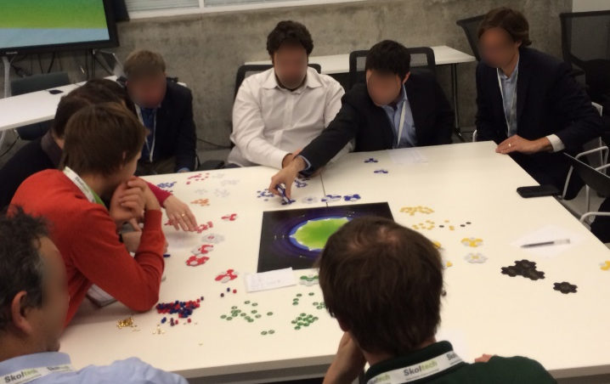
Orbital Federates is a simplified game to model space system operations and study collaborative (and non-collaborative) behaviors in a FSS. It uses a two-dimensional orbital space where spacecraft orbit the Earth with a period of six turns and pass over ground stations below. Each player controls a set of systems (spacecraft and ground stations) composed of subsystems (sensors, data storage, links, etc.). Subsystems provide functional behaviors to transform (sense), transport (send/receive), store, and exchange data. Randomly drawn events generate geographic demands to sense surface phenomena. Spacecraft overhead can sense, store, and, later, crosslink or downlink data to a ground station to receive revenue. Players establish their own contracts to govern use of shared assets. Players reinvest revenue in new system assets or save it to pursue the highest total net worth at the end of a 24-turn game.
Rather than serving as an experimental platform, Orbital Federates is an exploratory device to understand and experience federated system design. Gameplay stimulated development of a computational model to analyze design alternatives under various modes of collaboration. Orbital Federates Simulation – Python analyzes a tradespace of 503 design alternatives under game-theoretic strategies. Operational decisions are framed as a mixed-integer linear program (MILP) to optimally sense, store, and transmit data to maximize revenue subject to constraints. Results contrast systems engineering (SE) with system-of-systems engineering (SoSE) activities and demonstrate bounds to the value of collaboration. The independent strategy is a lower bound and a centralized strategy is an upper bound where a federation authority assumes all operational decisions. The value of any other federated strategy, such as an opportunistic fixed-cost service agreement, fall between these two cases.
P.T. Grogan and O.L. de Weck. "Interactive Simulation Games to Assess Federated Satellite System Concepts," 2015 IEEE Aerospace Conference, March 2015.
P.T. Grogan, K. Ho, A. Golkar, and O.L. de Weck. "Bounding the Value of Collaboration in Federated Systems," 2016 IEEE International Systems Conference, April 2016.
P.T. Grogan, A. Golkar, S. Shirasaka, and O.L. de Weck. “Multi-stakeholder interactive simulation for federated satellite systmes.” 2014 IEEE Aerospace Conference, March 2015.
Collaborative Design Game
This interactive model studies how a design team solves a series of a surrogate parameter design tasks. Each task includes N inputs and outputs distributed among n designers. The design goal is to place each output within an acceptable error tolerance of a target value by modifying inputs. Inputs and outputs are coupled by a linear system of equations expressed by a square M matrix. Tasks are randomized by composing orthonormal matrices and orthonormal target vectors. Typical task completion times range from seconds for problems with two variables to several minutes for ones with four variables.
Prior research shows individual designers require geometric growth in completion time with increasing numbers of design variables in contrast to algorithmic solutions with quadratic growth (e.g. Gaussian elimination). This difference is hypothesized to be related to cognitive limitations in working memory. The Collaborative Design Game extends this work by studying multi-actor design performance. A team has distributed cognition and experiences additional limitations from imperfect communication.
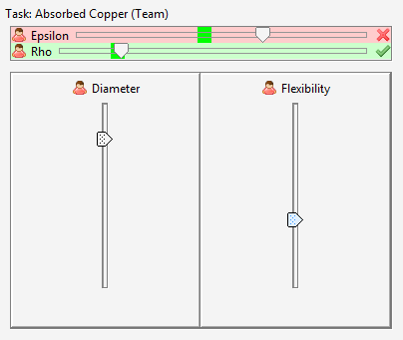
A distributed software application is implemented in Java with the IEEE Std. 1516-2010 High Level Architecture (HLA) for federated simulation. Each player controls a designer federate which publishes input values and subscribes to output values which are updated in real time. Graphical user interfaces are limited to qualitative affordances such as slider bars for inputs and outputs and players are not allowed to share screens. A researcher controls a manager federate which subscribes to input values and publishes output values using an underlying system model to map inputs to outputs and identify valid solutions.
A human subject study considered 24 tasks in partially-randomized order with varying problem size (N), team size (n), and degree of coupling (M diagonal or complete). Participants include 10 groups of 3 volunteer subjects yielding 376 data points after removing 46 missing data points. Hierarchical or multi-level regression analysis considers fixed and random effects to handle correlation across repeated measures from subjects. Results replicate prior findings of geometric growth in completion time for singles and show similar effects for pairs and triads. Results also show a super-linear growth in completion time for teams of increasing size. Interestingly, no significant interaction effect was found between problem size and team size, i.e. these factors appear to be able to be considered separately.
P.T. Grogan and O.L. de Weck. "Collaboration and complexity: An experiment on the effect of multi-actor coupled design," Research in Engineering Design, February 2016. Early access.
P.T. Grogan. “Perception of Complexity in Design,” 2016 Conference on Systems Engineering Research, March 2016. In review for Systems Engineering.
F. Flager, D.J. Gerver, and B. Kallman. "Measuring the impact of scale and coupling on solution quality for building design problems." Design Studies, Vol. 25, No. 2, 2014.
N.W. Hirschi and D.D. Frey. "Cognition and complexity: An experiment on the effect of coupling in parameter design." Research in Engineering Design, Vol. 13, 2002.
Sustainable Infrastructure Planning Game
Sustainable infrastructure planning calls for collaborative, systems-based approaches to transform legacy infrastructure, assess long-term behaviors, and anticipate interdependencies across traditional sector-based boundaries. In other domains, methods such as concurrent engineering allow designers to share technical data in a computational environment; however, a central actor, the systems engineer, adjudicates decisions to achieve global objectives. In contrast, serious games take a more decentralized perspective on design decisions but underlying software components are developed by a research lab or studio without the distributed control characteristic of infrastructure systems. Interoperable simulation gaming enables rich exchange of technical data during an interactive design session across organizational boundaries. It uses interoperable simulation standards such as the IEEE Std. 1516-2010 High Level Architecture (HLA) to establish common object models, operational agreements, and synchronization mechanisms to operate a distributed simulation.
The Sustainable Infrastructure Planning Game is a prototype to assess feasibility of interoperable simulation gaming. Its design scenario puts three players in control of water, energy, and agriculture infrastructure in the fictional desert nation Idas Abara. Players propose a 30-year strategic plan comprised of infrastructure projects in three regional zones to balance local and national objectives within budgetary constraints on capital expenses. National objectives seek to improve domestic food supply, sustainability of water and petroleum withdrawals, and economic revenue while local objectives reinforce water-agriculture (irrigation) and water-energy (budget) tensions. A simulation model and graphical user interface implemented in Java allows players to visualize and share technical details pertaining to resource flows within their sector-specific infrastructure system.
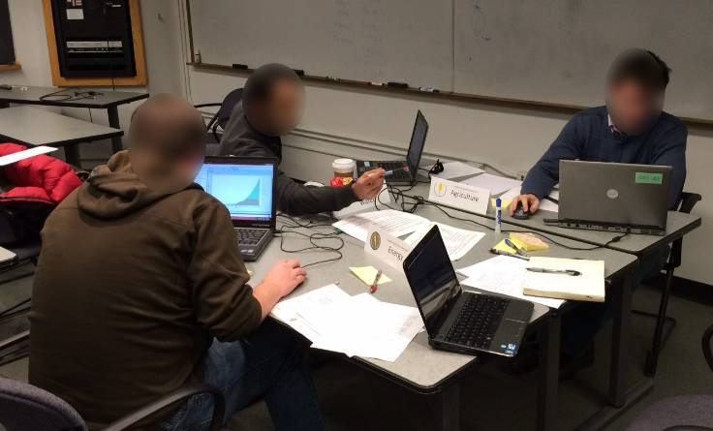
The Sustainable Infrastructure Planning Game also serves as an experimental platform to study collaborative design. A preliminary human subjects study used two variants of the simulation tool: an asynchronous variant with input-output file exchange via a shared network folder and a synchronous variant with the HLA. Fifteen teams of three subjects participated in a 60-minute design scenario. Results show a positive correlation between national objective outcome rank and number of data exchanges, irrespective of the tool variant. Results also show the synchronous tool yields more data exchanges than the asynchronous tool. These results suggest data exchange frequency, supported by synchronous tools such as an interoperable simulation game, improve design for global objectives such as sustainability.
P.T. Grogan and O.L. de Weck. "Collaborative Design in the Sustainable Infrastructure Planning Game," 2016 Spring Simulation Multi-conference Annual Simulation Symposium, April 2016.
P.T. Grogan and O.L. de Weck. "Infrastructure System Simulation Interoperability Using the High Level Architecture," IEEE Systems Journal, August 2015. Early access.
P.T. Grogan and O.L. de Weck. "The ISoS Modeling Framework for Infrastructure Systems Simulation," IEEE Systems Journal, vol. 9, no. 4, December 2015.

